EXPERIMENT 5: A PRODUCT SELLING SYSTEM USING ZOHO CREATOR
Aim:
To develop a Product Selling System using Zoho Creator, a cloud-based SaaS platform, that allows users to enter product details, automatically calculates the total selling amount, and stores product records in the cloud.
Procedure
Step 1:
Log in to Zoho Creator.
Step 2:
Click Create New Application.
Step 3:
Enter the application name as: Product Selling System
Step 4:
Create a form named: Product Selling System
Step 5:
Add the following fields:
Field Name | Field Type
Product Name | Single Line
Category | Drop Down
Quantity | Number
Price | Currency
Total | Currency
Seller Name | Name
Phone Number | Phone
Step 6:
Create a workflow to calculate the total amount automatically.
if(input.Price != null && input.Quantity != null)
{
input.Total = input.Price * input.Quantity;
}
Step 7:
Create an On Success workflow to display a confirmation message. alert "🛒 Product Order Successful!\nThank you for shopping with us.";
Step 8:
Create a report named Product Selling Report to display all product selling records.
Step 9:
Run the application, enter product details, submit the form, and verify that the total amount is calculated automatically and the confirmation message is displayed.
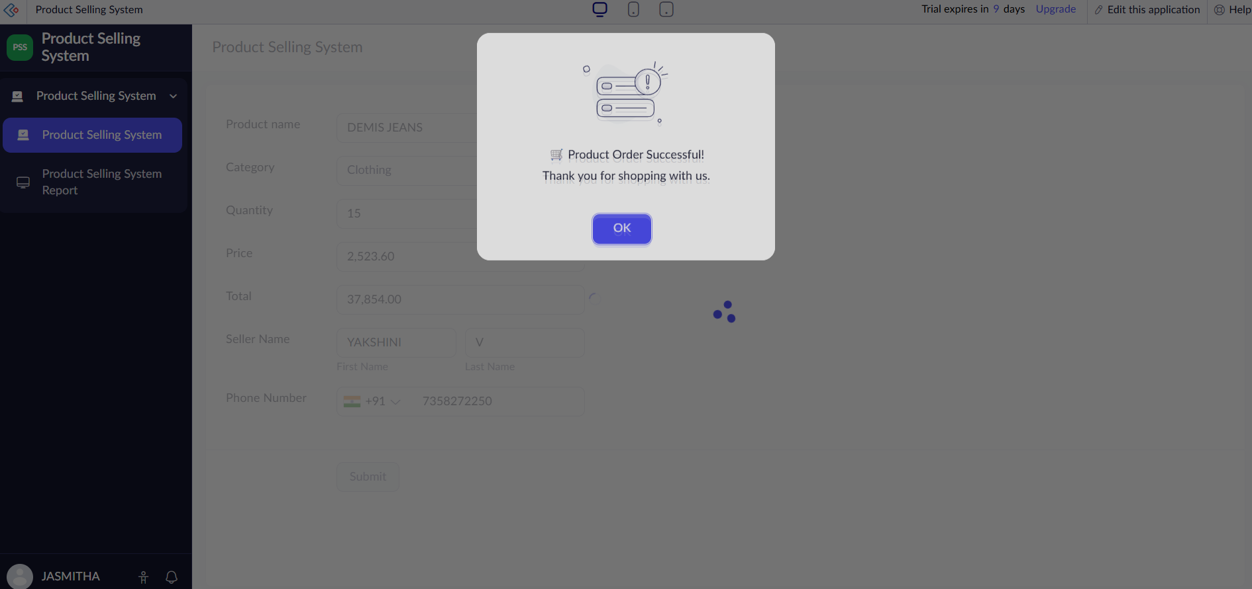
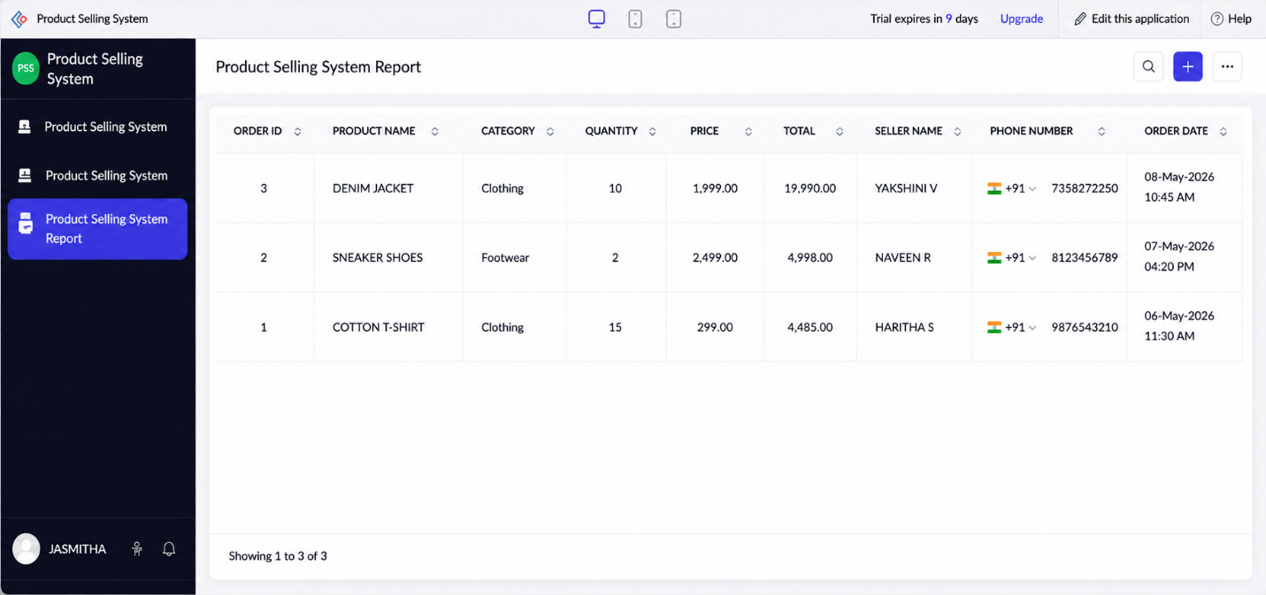
Implementation
The Product Selling System was implemented using Zoho Creator forms, workflows, and reports. The system allows users to enter product details such as product name, category, quantity, price, seller name, and phone number. The total selling amount is automatically calculated based on the product price and quantity using a workflow. After the product details are successfully submitted, a confirmation message is displayed to the user. The product information is securely stored in the Zoho Creator cloud database, and reports are generated to manage product selling records efficiently, demonstrating the Software as a Service (SaaS) model.

